PRAY BEFORE YOU SPEAK (by Giovanna Payne)

GIOVANNA PAYNE is a wife and mother of three teenage children, teacher of RE and Philosophy and a popular conference speaker. Her passion is to equip people to walk in freedom and joy through the Word of God.

Positive Speaking
Our words have great power to bless or harm, 'Death and life are in the tongue' (Proverbs 18:21). And the most powerful voice that will shape our lives is our own and we are in control of it. Instead of declaring negativity in our heads, we can speak words of hope and blessing. Just Stop! We can ask the Holy Spirit to help us 'Tame the tongue' (James 3:1). Sometimes it is better to say nothing at all if we have nothing positive to say. We can become like Mary who, with God's help, learnt to 'Ponder things deeply in her heart'.
Find The Truth
God has spoken life-changing promises over each of us and we have them written in our Bibles. Such as: I am God's beloved child; He lives in me; My mind has been renewed; I am free etc When you find a biblical promise, write it out and learn to speak it over yourself daily in faith.
Give Thanks and Bless
What effect do our words have on others? Do we bless or curse, bring life or death? We can pray for the grace to stop complaining, blaming and defending ourselves. Let us pray often 'May the words of my mouth be pleasing to you, O Lord' (Psalm 19:15).

Opening prayer
Holy Spirit, I open my heart to You and invite You to teach me to pray
like Jesus. Please take me into the Father’s presence and empower
my soul from strength to strength.
Amen.

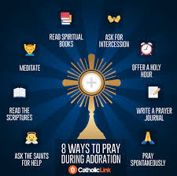

Eucharistic Adoration
Know also that you will probably gain more by praying fifteen minutes before the Blessed Sacrament than by all the other spiritual exercises of the day. True, Our Lord hears our prayers anywhere, for He has made the promise, ‘Ask, and you shall receive,’ but He has revealed to His servants that those who visit Him in the Blessed Sacrament will obtain a more abundant measure of grace.” – St. Alphonsus Liguori

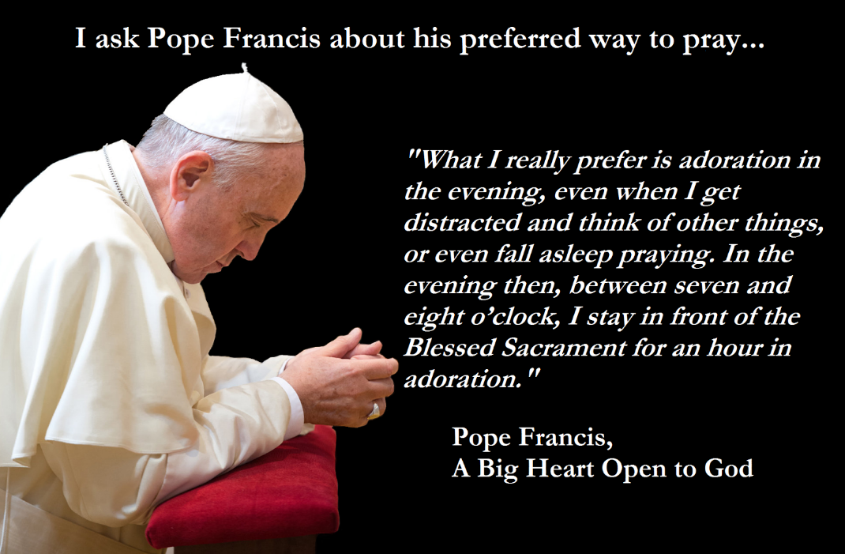
In the parish of OLOL Wanstead, Eucharistic Adoration is available from 8:30am to 9:00am Monday to Thursday and Saturday morning. While on Friday from 9:30am to 4pm, and then 7pm-9pm.

Useful websites
http://www.ourladyoflourdeswanstead.com/ Our parish website
https://catholic-link.org/ Infographics on a range of topics
https://clicktopray.org Worldwide prayer network from the Vatican.
http://www.cbcew.org.uk/home/events/the-god-who-speaks/
http://www.vatican.va/content/vatican/en.html Full resources of the Catholic Church in many different languages, as well as the latest from Pope Francis.
https://www.biblegateway.com/ Online Digital versions of the Bible
https://wordonfireinstitute.com/principles Bishop Barron site who is very active on social media and presented the Catholicism course
https://mycatholic.life/ You can get a daily reflection on the daily mass readings emailed to you. As well as a wealth of other spiritual readings.
www.whatgoodnews.org Brentwood initiative for the Year of the God Who Speaks, but includes reflections on all the Sunday Gospels, as well as videos of many talks given in the diocese, including the God Who Speaks series
http://www.therealpresence.org/ Many interesting articles relating to Eucharist Adoration and the Real Presence

This leaflet will be available on the parish website under Advent Talk 3. If you open it there you will be able to press Control and Left Click in order to go straight to the websites. There are myriad websites out there. Have you a favourite you would like to share? Pass it on to Michaelaololcc@gmail.com

