FOOD FOR THOUGHT (by Giovanna Payne)

GIOVANNA PAYNE is a wife and mother of three teenage children, teacher of RE and Philosophy and a popular conference speaker. Her passion is to equip people to walk in freedom and joy through the Word of God.

Transformed
One of the most hopeful promises in the Bible is in 2 Corinthians 3:18 'We are being transformed into His likeness from glory to glory'. The big challenge is how to survive the days when we don't feel very 'transformed'.
The Battleground
The Bible says that our mind and memory play a vital part in our faith journey. It is very easy to forget the basic truths of God's love and mercy and start to believe the opposite. Over time we can develop ways of thinking negatively about ourselves, others and even God!
Renew Your Mind
The Bible is full of practical advice about changing our thinking patterns. In Ephesians 4:22 we are told to 'Strip off our un-renewed self and put on our new nature.' And St Paul goes onto say 'Be constantly renewed in the spirit of your mind!'
Choose To Choose
This process of renewal is a daily thought by thought challenge. St Paul also says, 'Take every thought captive into obedience to Jesus' (2 Corinthians 10:5). If we replace the lies in our head with God's truth about us, slowly but surely, we will be free!
Giovanna’s prayer life is structured through her study of the Bible. She has her favourite verses and that list is provided on the parish website, Advent Prayer Talk 2 page. She encourages us all to spend time with our Bibles and find readings that speak to our personal situation.

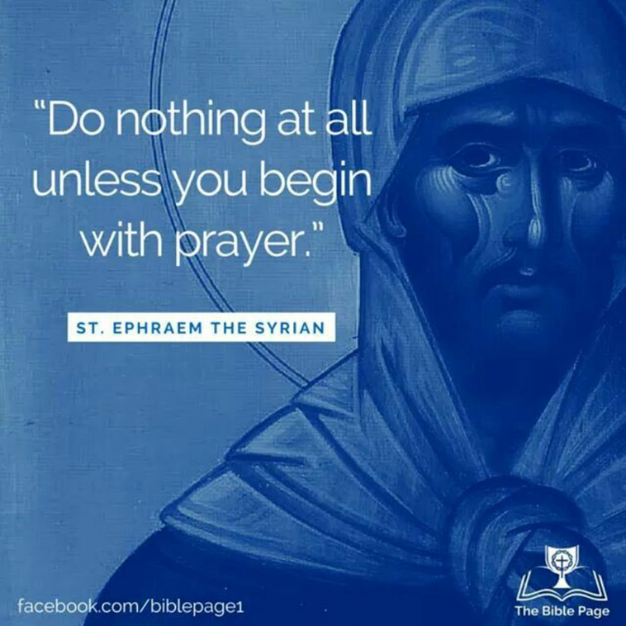
Opening prayer
Holy Spirit, I open my heart to You and invite You to teach me to pray
like Jesus. Please take me into the Father’s presence and empower
my soul from strength to strength. Amen.

Prayer in the Catechism of the Catholic Church (CCC)
‘By prayer we can discern what is the will of God and obtain the endurance to do it.’ CCC2826
‘Prayer restores us to God’s likeness and enables us to share in the power of God’s love.’ CCC 2572
Quotes from St Ephrem the Syrian – Doctor of the Church
When you begin to read or listen to the Holy Scriptures, pray to God thus: "Lord Jesus Christ, open the ears and eyes of my heart so that I may hear Thy words and understand them, and may fulfil Thy will." Always pray to God like this, that He might illumine your mind and open to you the power of His words. Many, having trusted in their own reason, have turned away into deception.

The word of God is a tree of life that offers us blessed fruit from each of its branches. It is like that rock, which was struck open in the wilderness, from which all were offered spiritual drink. Be glad then that you are overwhelmed, and do not be saddened because he has overcome you. A thirsty person is happy when drinking, and not depressed, because the spring is inexhaustible. You can satisfy your thirst without exhausting the spring; then when you thirst again, you can drink from it once more.
Scripture brought me to the Gate of Paradise, and the mind stood in wonder as it entered. 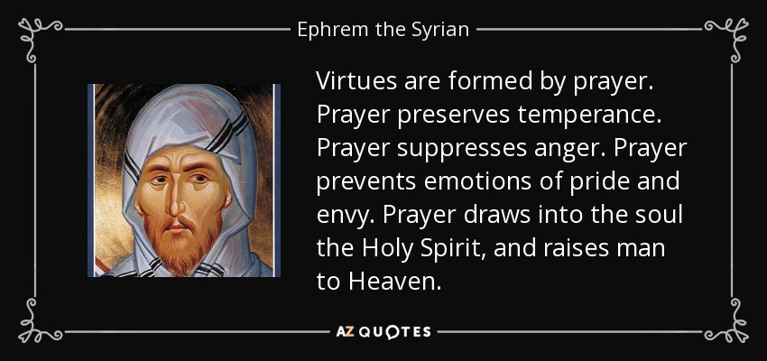
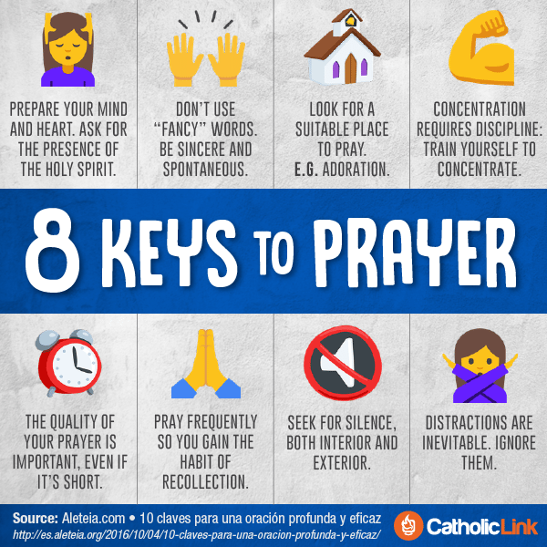
https://catholic-link.org/
