THE LIFE OF PRAYER (by Fr Emmanuel Mansford)

FR EMMANUEL MANSFORD CFR is a Friar of the Renewal currently based in New York City. He is a much sought-after speaker and Spiritual Director featured in the CaFE series 'Saints - helping us today'.
Our Deepest Desire
What is your deepest desire? Psalm 63 shows us that hunger for more of God is our goal! God wants each of us to be in deep, intimate union with him making us holy and blameless. This union will cost us like anything else of value. We must bring our wills in line with God's will.
Disposition of Prayer
The Catechism reminds us that there is a battle of prayer often holding us back (CCC2725-45). Some days our 'spirit feels willing' but our flesh lets us down and we give up on our prayer life. But daily faithfulness in prayer pleases God and we must learn to pray in a way which works for us.
The Privilege of Prayer
What a joy it is to mediate silently on the wonder of God's love for us each day. We need to quieten our lives so we can begin to hear God's quiet voice in our hearts. This is a skill that comes with practice and at times we may pray without 'feeling' very spiritual.
Be Real In prayer
God shines his light into our hearts to show us the whole truth about ourselves. This insight will set us free (John 8:32) to be fully alive to God and to others. We can spend time being healed everyday as we meditate on God through his Word.

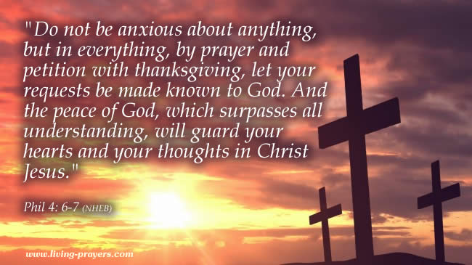

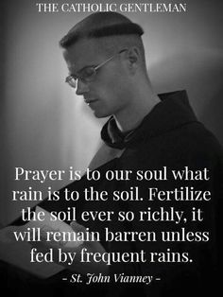
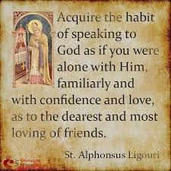

Opening prayer
Holy Spirit, I open my heart to You and invite You to teach me to pray like Jesus. Please take me into the Father’s presence and empower my soul from strength to strength. Amen.

Prayer in the Catechism of the Catholic Church (CCC)
‘By prayer we can discern what is the will of God and obtain the endurance to do it.’ CCC2826
‘Prayer restores us to God’s likeness and enables us to share in the power of God’s love.’ CCC 2572
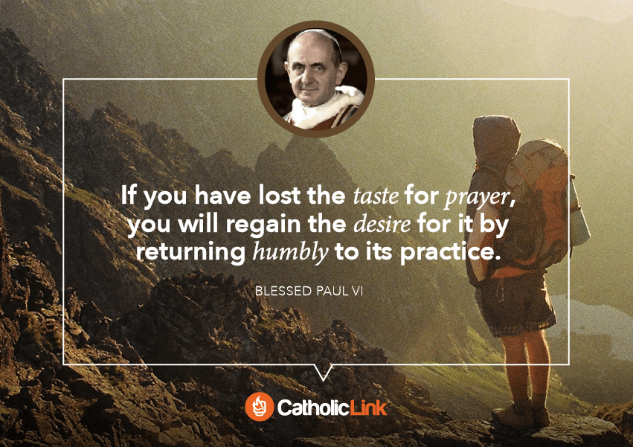

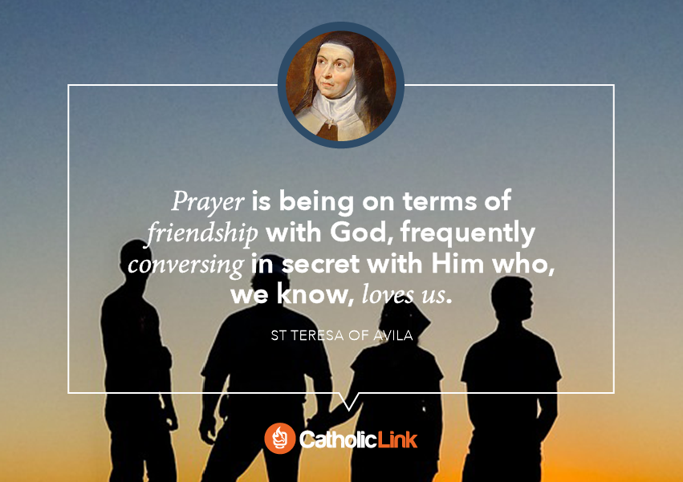
https://clicktopray.org/

December 3rd 2019 – Feast of St Francis Xavier

Today 175 years ago a group of Jesuit students felt frustrated because of their desire to go to the missions but could not. Their formator invited them – on the feast of St. Francis Xavier – to be missionaries striving to be available to Christ to fulfil their daily obligations. Thus they gave a new meaning to their daily activities and established the Apostleship of Prayer, today known as the Pope’s World Prayer Network. How do you live your daily activities? Do you strive to fulfil your obligations well?
In 2018 the Click to Pray app was introduced and now you can receive daily prayers in support of Pope Francis’s theme for the month. This month: Let us pray that every country take the measures necessary to prioritize the future of the very young, especially those who are suffering.

